Dual booting exercise 1:
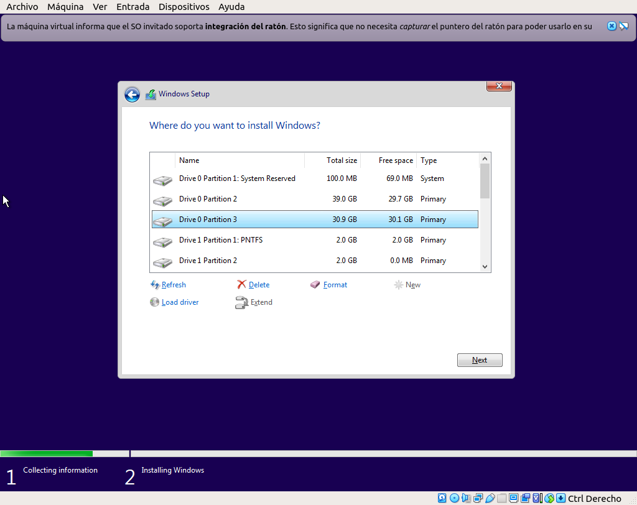
We install Windows 10 on the free partition of Drive 0.

Then, when the installation is complete, the computer will restart and we will have to choose between Windows 10, Windows 7 or Change defaults. We click on Change defaults and we will see this screen.

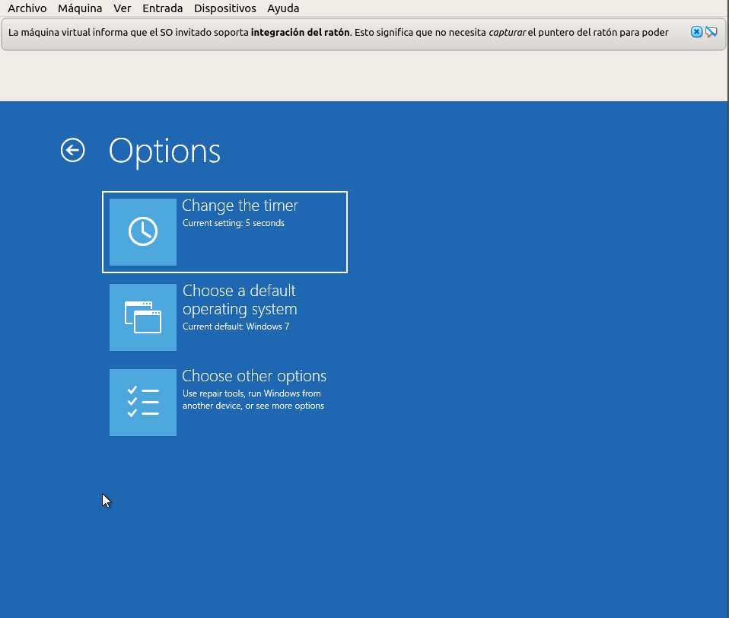

Here we choose a 5 second timer, and Windows 7 as the default operating system.
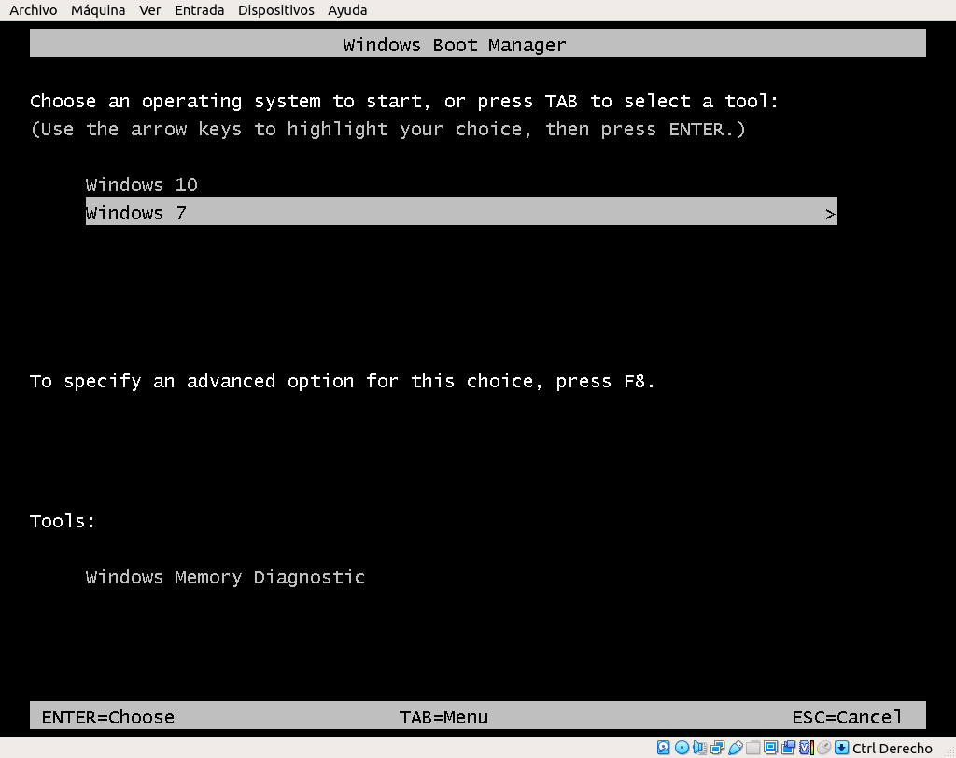
If we restart we will see the following screen. And the exercise would be complete.

